

ELectronics Engineering Students’ Association(ELESA)

Presents

ELECTROVERT 2018

The Performers’ creed

Name of the Event: **Circuit-Tech (Novice) Round2**

Candidate’s Code:

z

* All **questions** are compulsory.
* All questions are compulsory and carries equal amount of marks.
* Use of calculators is allowed.
* Use of mobile is strictly prohibited.

Date:**09 Sept 2018**

Time:**45 min**

1. How much current flows in the given circuit?

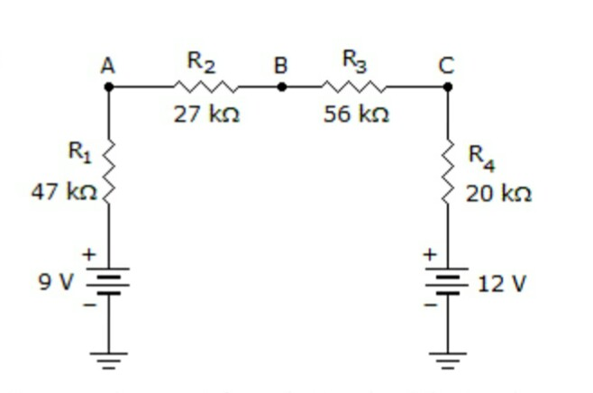

1. What is the total resistance?

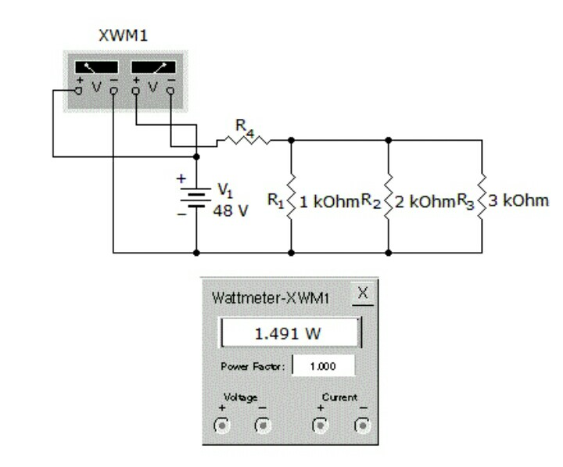

3.Find iC2 (Si BJT with β1=100 and β2=50).

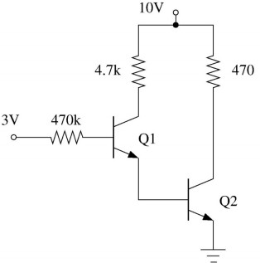

4.

In the figure, D1 is a real silicon pn junction diode with a drop of 0.7V under forward bias condition and D2 is a zener diode with breakdown voltage of −6.8V. The input Vin(t) is a periodic square wave of period T, whose one period is shown in the figure.

Vin(t) 10 μF

D1

D2

V

out

(

t

)

+

14

V

−

14

V

t

(

Sec)

)

0

T



10

Ω

Assuming 10 τ ≪ T. Where τ is the time

constant of the circuit, the maximum

and minimum values of the output waveform

are respectively?